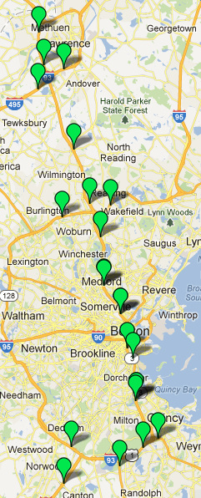I-93 RTTM Sign Locations  2E  2F  2D  2C  2A  2B  0E  0C  0D  0A  0F  0B  1F  1A  1E  1C  1B  1D  3A  3B  3C  3D | I-93 RTTM Travel Time Routes  Sign From To Dist. (Mi) Free Flow Time (Min)  3D I-93 SB after Pelham St. in Methuen I-93 SB before I-95 in Woburn 16 14  3C I-93 SB before I-495 in Andover I-93 SB before I-95 in Woburn 13 12  3A I-495 NB before I-93 in Andover I-93 SB before I-95 in Woburn 13 12  3B I-495 SB before I-93 in Andover I-93 SB before I-95 in Woburn 14 13  1D I-93 SB before Rt. 62 in Wilmington I-93 SB before I-95 in Woburn 5 5  1C I-93 SB before I-95 in Woburn I-93 SB after Cambridge St. in Somerville 11 11  1B I-95 NB after Winn St. in Burlington I-93 SB after Cambridge St. in Somerville 12 13  1E I-95 SB before Rt. 28 in Wakefield I-93 SB after Cambridge St. in Somerville 12 12  1A I-93 SB before Fallon Rd. in Stoneham I-93 SB after Cambridge St. in Somerville 7 8  1F I-93 SB before Rt. 16 in Medford I-93 SB after Cambridge St. in Somerville 3 4  0B I-93 NB before Rt. 16 in Medford I-93 SB before I-95 in Woburn 8 8  0F I-93 SB after Cambridge St. in Somerville I-93 SB before Mass Ave. in Boston 4 5  0A I-93 NB before Cambridge St. in Somerville I-93 SB before I-95 in Woburn 11 11  0D I-93 SB before Mass Ave. Conn. in Boston I-93 NB before Granite St. in Braintree 10 11  0C I-93 NB after Columbia Rd. in Boston I-93 NB before Cambridge St. in Somerville 5 7  0E I-93 SB after Granite Ave. in Milton I-93 NB before Granite St. in Braintree 5 6  2B I-93 NB after Granite Ave. in Milton I-93 NB after Columbia Rd. in Boston 4 5  2A Rt. 3 NB before I-93 in Braintree I-93 NB after Columbia Rd. in Boston 8 9  2C I-93 NB before Granite St. in Braintree I-93 NB after Columbia Rd. in Boston 9 10  2D Rt. 24 NB before I-93 in Randolph I-93 NB before Granite St. in Braintree 3 4  2F I-95 SB before University Ave. in Westwood I-93 NB before Granite St. in Braintree 7 8  2E I-95 NB after Neponset St. in Norwood I-93 NB before Granite St. in Braintree 9 9

